**Ideation Phase**

**Brainstorm & Idea Prioritization Template**

|  |  |
| --- | --- |
| Date | 19 September 2022 |
| Team ID |  |
| Project Name | Smart Fashion Recommender Application. |
| Maximum Marks | 4 Marks |

**Brainstorm & Idea Prioritization:**

* This application provided the feature of direct interaction with **CHATBOT** .
* It also provide with the **TIPS** ,that shows the user regarding fashion sense or use of product in different ways.
* It provides with exact occasional wears as use needs.

**Step-1: Brainstorm, Idea Listing and Grouping**

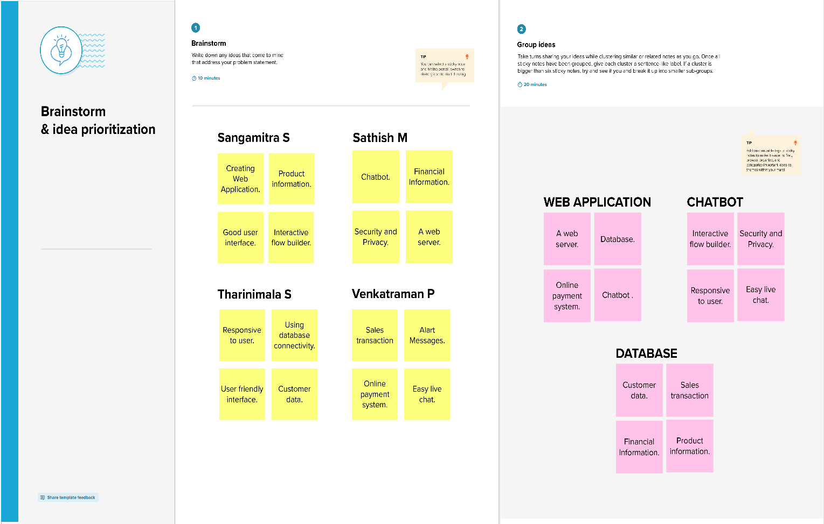

**Step-2: Idea Prioritization**

**Reference:** <https://app.mural.co/t/msspace9371/m/msspace9371/1666946176738/59a5d07b02525e13fae0bcc62a574fba24911a1e?sender=u1935d831ed15f292598d9406>